Come join the Child Development Center as wea
Journey to the
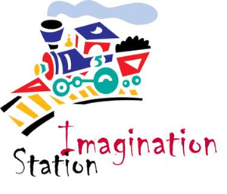
Summer Session: June 1 – July 22

- Use your imagination! (Dramatic Play)
2. Fun with Paint and Paper!
3. Clay Creations
4. Box-o-palooza (Creative fun with boxes)
5. Music Madness
6. Playtime with Blocks
7. Creative Cooking
8. Spectacular Science!

Call 541-3175 for information on enrollment
preschool@stpaulslascruces.com

